14 Responsive Sites

Contents

Turn on Sass 1

Adding a Mixin 1

Home Page responsive design 3

The Medium Media Query 3

About Page Responsive Design 5

Project Page Responsive Design 6

The Large Media Query 8

The Contact Page 10

Extra Large Project Page 12

Creating a Mixin for Super small screens 15

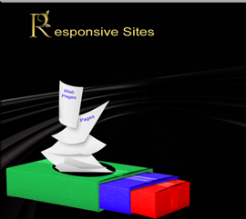

# Turn on Sass

In Visual Studio

Remember to turn on your Watch Sass



# Adding a Mixin

Go to your config.scss partial file



@mixin media-md{

@media screen and (min-width: 768px) {

@content;

}

}

Copy and Paste 2 more Sizes



Make these changes to the new two media queries

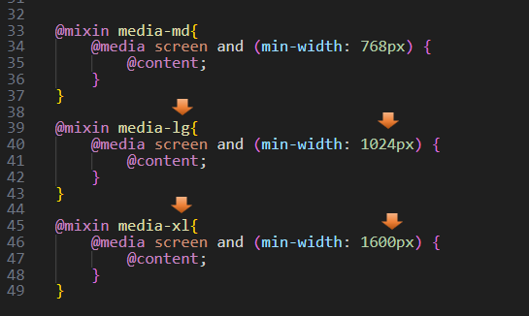

Start a New Partial responsive.scss File

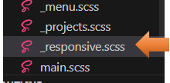

Go to the main.scss file



@include new File in main.scss

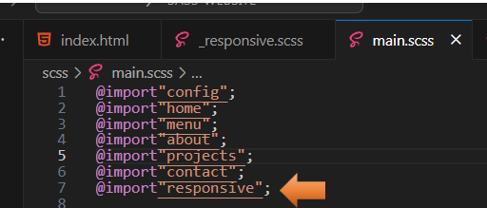

# Home Page responsive design

## The Medium Media Query

Go to Your Partial responsive.scss File

We will begin to write our code for the home page.

Start by @including your mixin media queries. Start with the smaller sizes and work our way up

@include media-md {

}

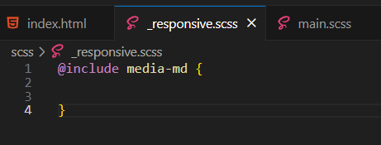

Now start to write your code inside of this media query

@include media-md {

.menu-btn {

visibility: hidden;

}

.nav {

visibility: visible;

.menu-nav {

display: block;

transform: translateY(0);

height: 100%;

background:transparent;

text-align: right;

&__item {

display: inline;

padding-right: 1.5rem;

}

&__link {

font-size: 1.5 rem;

}

}

}

}

Test the Page

Go to index.html to test the page. You will notice when we hit a wider screen size, the layout will change from viewing the small hamburger menu to a navigational menu across the top of the page.

Smaller device design



Wider device design



# About Page Responsive Design

On this page, we will be making the text just a bit bigger as we go from a smaller device to a wider screen size.

Still in your responsive.scss partial file. We want to still be inside of the media queries, so start your code right before that closing curly brace.

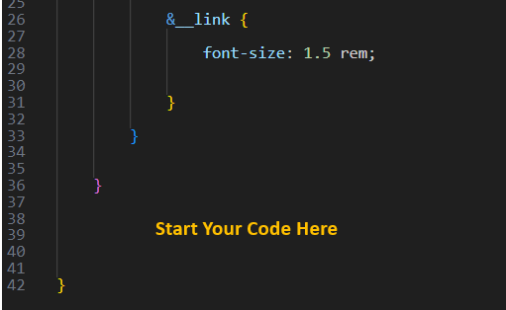

.about__bio {

font-size: 1.5rem;

}

# Project Page Responsive Design

Again, you will want to be inside of that same media code and then start writing your code right before the closing curly brace again.

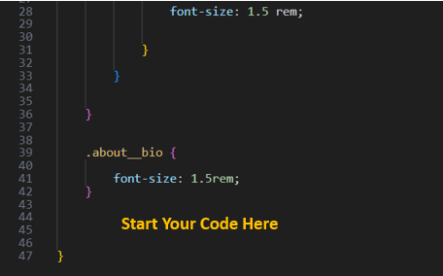

.projects {

&__bio-image {

height: 55vh;

}

&__items {

grid-template-columns: repeat(2, 1fr);

}

.text-secondary {

font-size: 3rem;

}

}

Test the Medium Projects page

Save and see what we have for our projects page

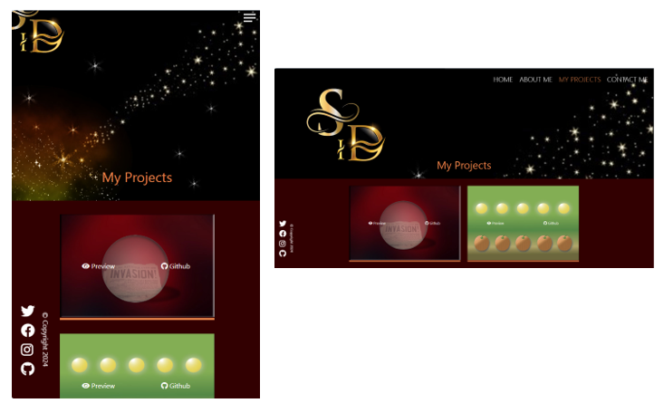

Projects page Sass Code Continued

You are still inside of the last curly brace for the medium Media Query

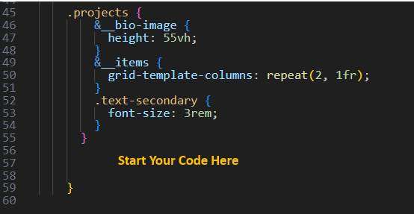

.contact__list {

grid-template-columns: repeat(2, 1fr);

}

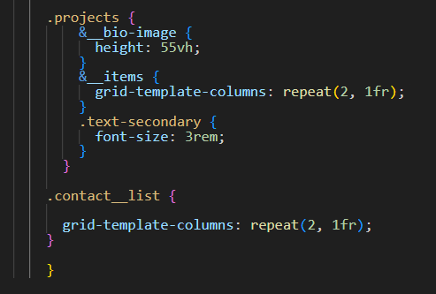

## The Large Media Query

We are still working on the Responsive file, but since we are starting a brand-new media query, we want to make sure we are below any of our previous closing curly braces.

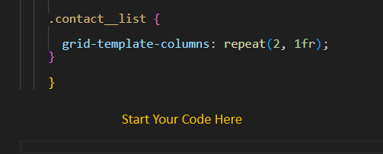

Projects page

Let’s start working in our responsive file for the Projects page. We want our project page to go to three columns on the large screen size for the portfolio images on that page.

@include media-lg {

.projects {

&__items {

grid-template-columns: repeat(3, 1fr);

}

}

}

Notice that when we want our images to show three across, we have changed our repeat to 3. So, that is where the code is that will control that section of our layout.

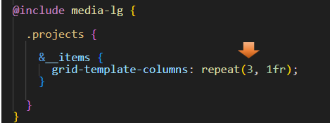

Testing the Large screen Page

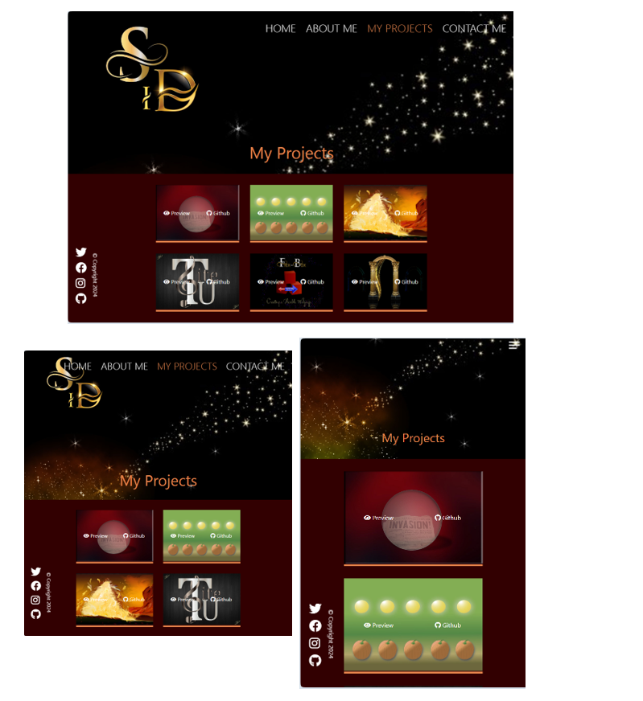

## The Contact Page

You are starting this code, before the closing curly brace of the media-lg media query.

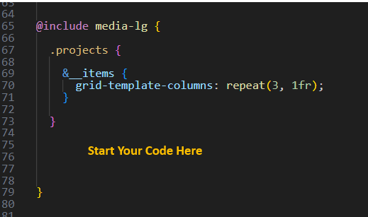

.contact__list {

grid-template-columns: repeat(3, 1fr);

}

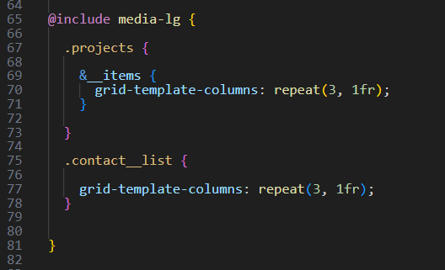

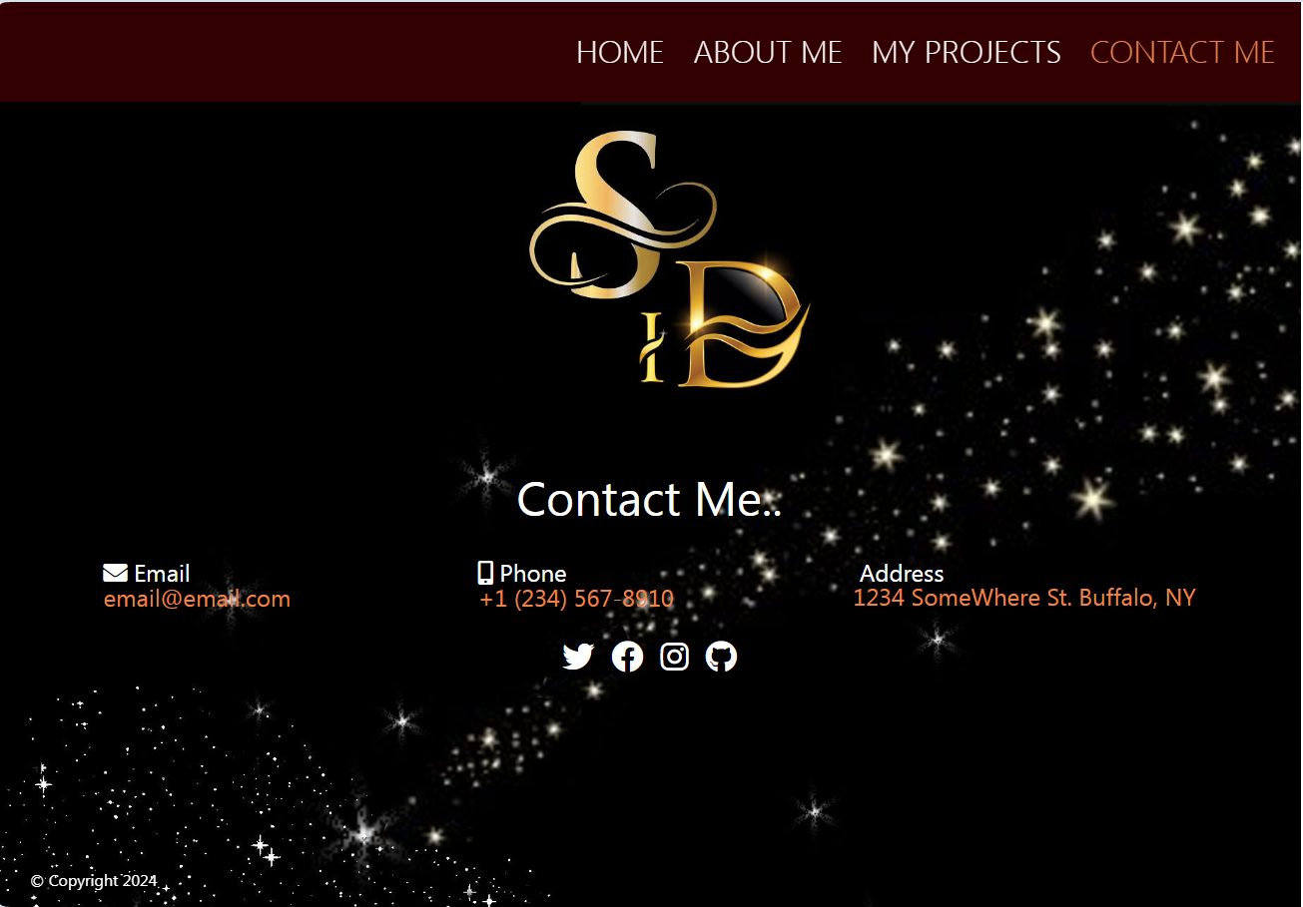

# Extra Large Project Page

You will see that the letters of the logo are cut off just a bit in the extra large size of screen

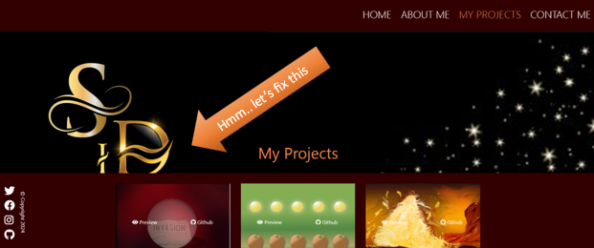

So, to fix this we want to make the image’s height a bit larger.

@include media-xl{

.projects__bio-image {

height: 70vh;

}

}

At the very bottom of the Responsive page file, we will put this code

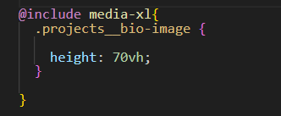

Now the gold letter logo fits on the page.

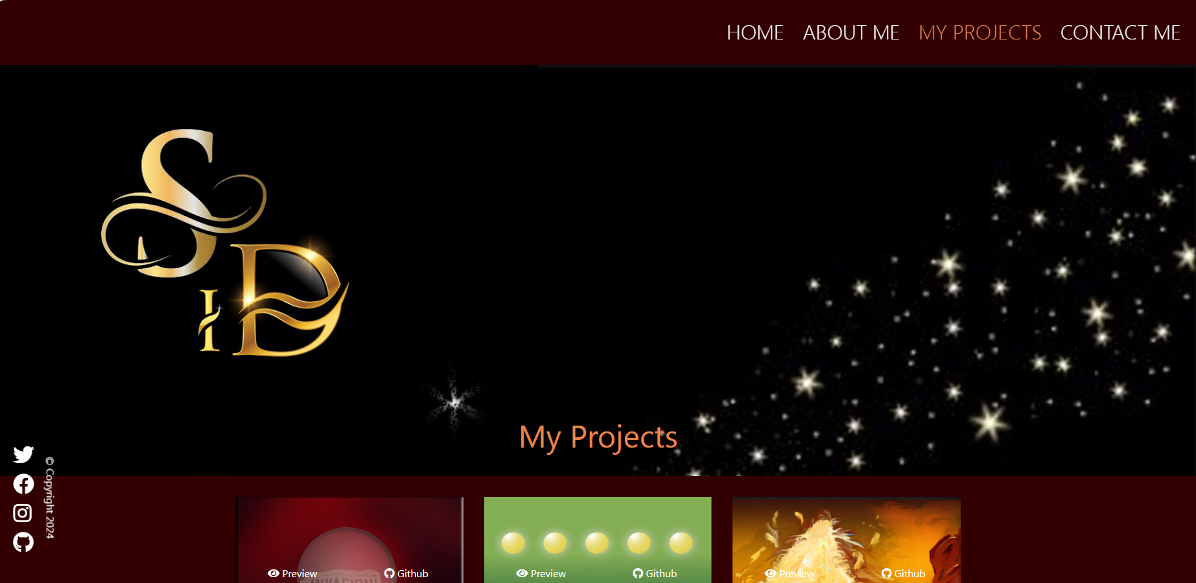

The About Page

We found that we had the same problem with the logo cutting off on the about page. See how the text for the BIO in this section, goes over the gold letter logo

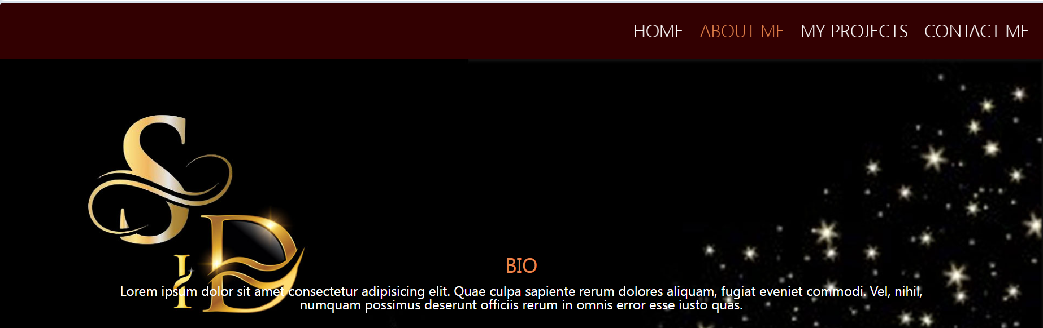

.about__bio-image {

height: 70vh;

}

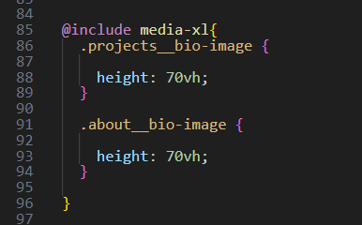

Now that looks a bit better.

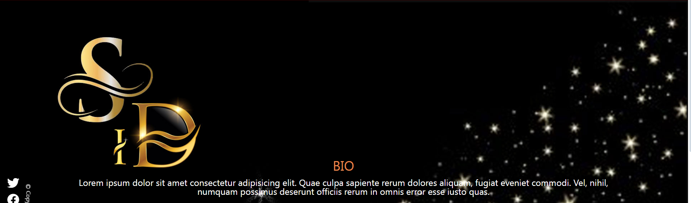

# Creating a Mixin for Super small screens

Most phones will probably not be this small and you will not have this issue with your layout. However, you might find you have this problem while testing, even if it more than likely will not be an issue for your users or once you are using an actual cell phone. if I was to test on the desktop for the smallest cell phone size, it will reduce smaller than a phone, and I would have this issue with the layout. I could just redesign my image and pull the logo to the right in Photoshop, but I also could just create a mixin for this smaller size issue.



In your config partial file

You will want to add this new smaller rule to your mixins. Some of you might be asking why we just did not make this change in our medium sized query. The reason that we could not just make the changes to the bio image in the medium sized mixin rule, and need to create a new rule is because creating the rule there, would mess with our hamburger menu, and you would no longer see it at your smaller cell phone levels. And that is something that would not work for us at all.

So, let’s start writing that smaller mixin.



@mixin media-sm{

@media screen and (min-width: 400px) {

@content;

}

}

In Your responsive partial file



Put this code at the very top of the file.

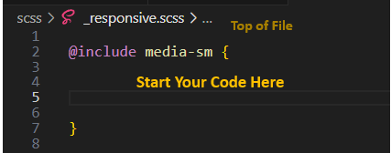

.projects {

&__bio-image {

width: 130vw;

}

}

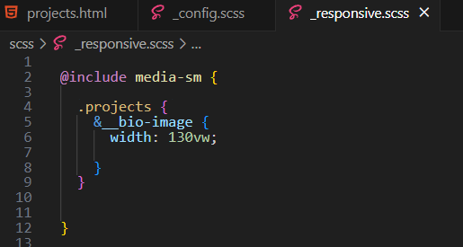

Testing

Now if we test that at a small size it is fixed, and our hamburger menu is still the navigational method that is visible.

